A COMPREHENSIVE ANALYSIS OF FINANCIAL PERFORMANCE: Insights from leading Banks.

***A Comprehensive Analysis of financial performance :Insights from leading banks****.*

**INTRODUCTION:**

**1.1 Overview**

A Healthy and vibrant economy requires financial system that moves funds from people who save to people who have productive investment opportunities. The financial system is complex in both structure and function throughout the world .It includes many different types of institutions :banks ,insurance companies ,mutual funds ,stock and bond markets ,etc. According to Sponge(2000),efficiently and competition are closely linked. In a competitive banking system ,banks must operate efficiently and utilize their resources wisely if they are to keep their customers and remain in business . Zerah et al..,(2013)also argued that survival in today’s competitive environment totally depends on performance and growth. Competition has implications for efficiency ,innovation, pricing ,availability of choice, consumer welfare, and the allocation of resources in the economy.

**1.2 Purpose**

Although banks do many things, their primary role is to take in funds—called deposits—from those with money, pool them, and lend them to those who need funds .Banks are intermediaries between depositors (who lend money to the banks) and borrowers ( to whom the banks lend money)There are other reasons to evaluate the performance of banks – to determine their operational results and their overall financial condition; measure their assets quality, management quality and efficiency, and achievement of their objectives; as well as ascertain their earning quality, liquidity, capital adequacy, and level of bank services. Bank performance analysis involves gathering formal and informal data to help customers and sponsors define and achieve their goals. Banks are also expected to provide evidence of their credit operations and financial flows as these influence the growth and economic development of the country.

**PROBLEM DEFINITION & DESIGN THINKING:**

**2.1 Empathy Map**

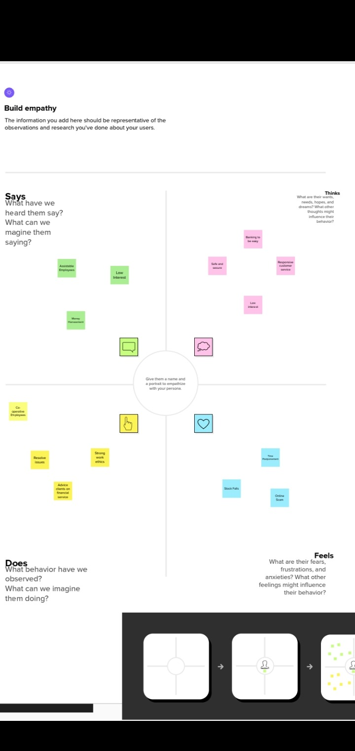

**2.2 Ideation & Brainstorming**

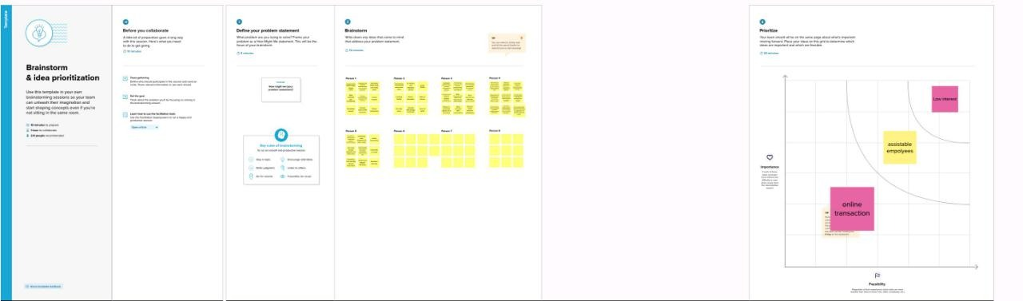

**RESULT:**

* Top banks according rank and assets.
* Top banks according to total assets.
* Top banks according to country based on total assets.
* Top 10 countries with assets proportion.
* Country with total assets using funnel chart in increasing order.
* Total assets analysis according to year and quarter.

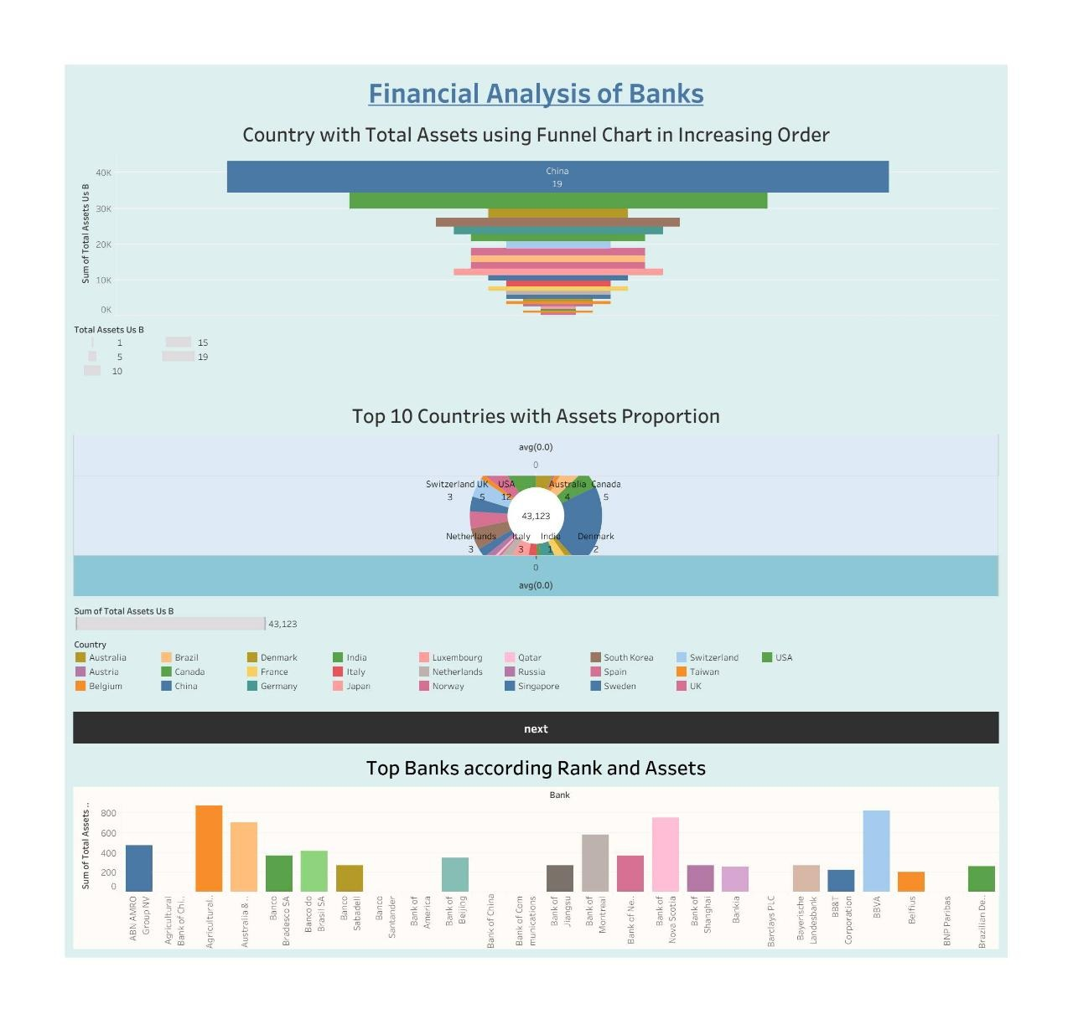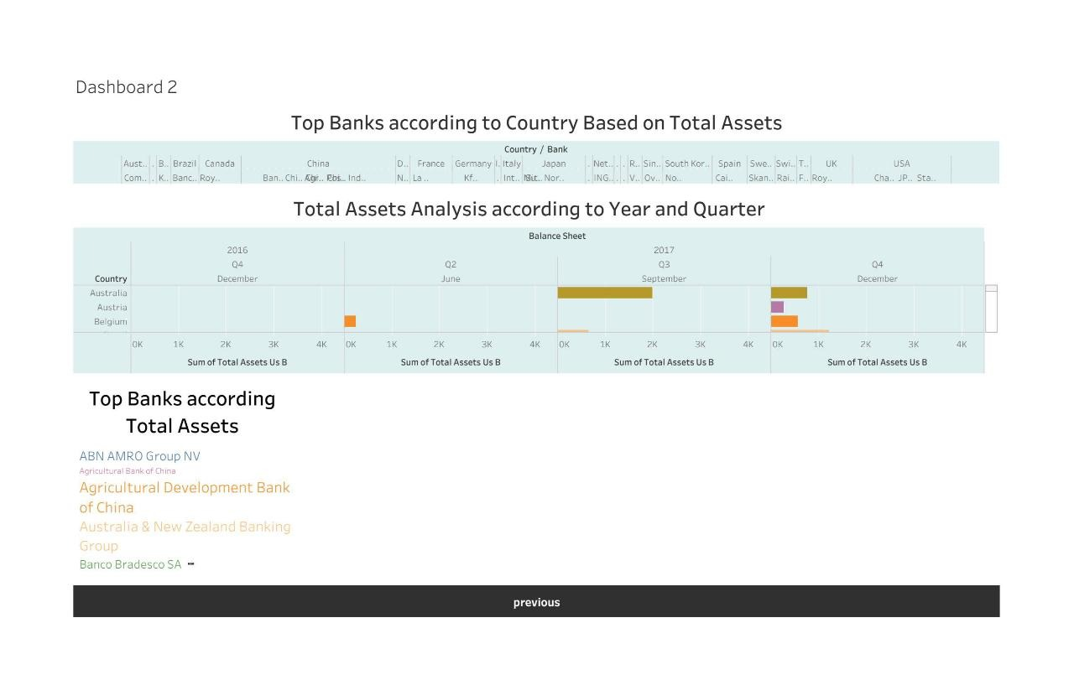

**ADVANTAGES & DISADVANTAGES:**

**Advantages;**

* A big benefit of using bank is that there are several types of bank accounts you can access for free or by paying low fee. Each account has a specific purpose and is designed to help you manage your money.
* Easily manage your money:

As you use your debit card, you’ll want the ability to track and control your spending. You can do this from your computer or mobile device using our free online and mobile banking tool, which makes banking easier and more convenient.

* Get unexpected income quicker.
* Protect your money.
* No fees to deposit your money :

When you receive a paper check from your employer, you can easily turn that check into money you can spend by cashing the check or depositing it into your account — without any fees.

**Disadvantages;**

* The most obvious drawback to modern banks is their fees. Many people work abroad to support their families and find a large chunk of their wages goes on transfer fees.
* The most common cause of bank failure occurs when the value of the bank's assets falls to below the market value of the bank's liabilities, which are the bank's obligations to creditors and depositors. This might happen because the bank loses too much on its investments.
* They include high management costs, availability of the banks only in cities, no job security, and high-interest rates for customers.
* Another disadvantage is that when you place money in a bank, you cannot invest the money. Instead, the money sits there securely, but it does not grow with time like an investing account.

**APPLICATION:**

* Financial analysis is used to evaluate economic trends, set financial policy, build long-term plans for business activity, and identify projects or companies for investment. This is done through the synthesis of financial numbers and data
* The evaluation of past financial performance, the projection of future financial performance, the assessment of credit risk, and the screening of potential equity investments.
* Analytics can be used to identify and rate individual customers who are at risk of fraud and then apply different levels of monitoring and verification to those accounts. Analysing the risk of the accounts allows banks and financial institutions to know what to prioritize in their fraud detection efforts.
* Financial analysis is used to evaluate economic trends, set financial policy, build long-term plans for business activity, and identify projects or companies for investment. This is done through the synthesis of financial numbers and data.
* The most important financial statement for the majority of users is likely to be the income statement, since it reveals the ability of a business to generate a profit. Also, the information listed on the income statement is mostly in relatively current dollars, and so represents a reasonable degree of accuracy.
* Financial data APIs (application programming interfaces) are pieces of software that interact with financial applications to facilitate information access, transactions, and payments

**CONCLUSION:**

Banking holds a crucial role in our day-to-day life. We must adhere to the banking system as responsible citizens. The banking system acts as a crucial base for the financial system as well as the entire economic system of the country. It provides a base to the market and the companies. For the savings and other economical aspects banks are the most reliable option for us where we can save, invest or borrow money by a given terms and conditions. That's why we can easily say that money and banking are the most important segment in the economic circumstances. Analysis of financial statements is extremely important for every business to grow and increase their revenue. It should not be compromised since it increases the efficiency of business operations. Better processes and expert analysts can help in the detailed analysis process.

**FUTURE SCOPE:**

The banking sector is at a turning point. Key measures for banks are at a historical low point. The sector’s price-to-book value has fallen to less than one-third the value of other industries. That gap is less the result of current profitability and more about uncertain profit growth in the future. While banks have pushed for great improvements recently, margins are shrinking—down more than 25 percent in the past 15 years and expected to fall to 30 percent, another 20 percent decrease, in the next decade. Regulation and increasing intersectional competition are still worries, but the bigger threat is a global trend: new challenges—often from different industries and often benefiting from the kind of cross-industry platforms behind the recent success of companies such as Amazon, Google, Microsoft, PayPal, and Spotify—with a vastly superior economic model. The market believes that banks are headed in the wrong direction, without a future-proof strategy.

We believe that the sceptics are right about today—and wrong about tomorrow. Banking is facing a future marked by fundamental restructuring. But we also believe that banks that successfully manage this transition will become bigger and more profitable and grow faster while leading to a value creation opportunity of up to $20 trillion. In the next era, banks can realign to compete in new arenas, organized around distinct customer needs. These arenas will expand far beyond the current definition of financial services, and they will also be hotly contested by a wide range of tech giants, tech start-ups, and other nonbanks. But this daunting reorganization, or breakup, could also provide banks with a huge opportunity: higher margins, new revenue streams, and loftier valuations .Ambitions banks can break free from stagnant valuations, thrive and grow if they are willing to embrace the platforms of the future and make a few strategic, information big bets.